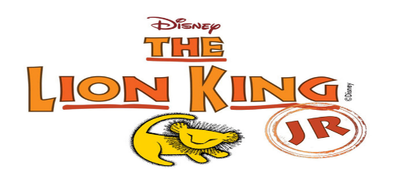NEWSLETTER (November, 2019)
Updates:
Thank you again parents and students for your support and commitment to this program. It takes a lot of dedication and team work to make it successful. We are making progress, though early and slow, it has been different and interesting at the same time, to learn about Africa and their languages for this production. The pronunciation is key and takes time so that we aren’t saying the wrong thing! LOL! Next, we will be learning how to perform in character. Are they human? Animals? Animals from the Serengeti? How do they move? Are we part of the natural habitat? What is the environment they are in like at the moment? It is pretty cool and it can be hilarious sometimes. This play entails a lot of teaching components which is different from any of the plays I’ve done before. Disney has done an AMAZING job with the package they provide for this production.
REHEARSALS: Rehearsals are going well. The kids are learning to manage their time between activities after school. Please contact me if they need to miss practice. I have a few who have missed more than 3 times. I will speak with them individually. One thing that I will revisit is grades and behavior. Please speak to your child about keeping up with their work at school first. This means studying and doing their homework. I remind them as well. I don’t want to lose any of my cast members due to grades
CAST T-SHIRTS: Cast t-shirts will be here soon! I can’t wait to see them! The cast members will be allowed to wear them every Monday with their PE shorts and school sneakers.
COSTUME UPDATE:
The cast has been measured and the costumes will be worked on in NY. If you want to see what they look like you can Google ” CNY costumes The Lion King Jr” . Our amazing Mrs Do and Mrs Benitez are making some of the ensemble costumes here and they are AMAZING!
Need: Donation of African print fabric
OTHER THINGS:
Halloween and Christmas come to an end there are a few things that I would like to borrow if you have any of them(please label them)…
*Smoke machines
* LED light projectors (projects like a spray of white lights on a house) 